Q1: What aspect of IP addresses makes it necessary to have one address per network interface, rather than just one per host? In light of your answer, why does IP tolerate point-to-point interfaces that have nonunique addresses or no addresses? – It is necessary to have one address per network interface, rather than one address per host because the host is used to find the address in the network, while the network has multiple number of hosts.

Q2: Suppose a TCP message that contains 1024 bytes of data and 20 bytes of TCP header is passed to IP for delivery across two networks interconnected by a router (i.e., it travels from the source host to a router to the destination host). The first network has an MTU of 1024 bytes; the second has an MTU of 576 bytes. Each network’s MTU gives the size of the largest IP datagram that can be carried in a link-layer frame. Give the sizes and offsets of the sequence of fragments delivered to the network layer at the destination host. Assume all IP headers are 20 bytes.

TCP Header has 1024 Bytes

Size of IP datagram = 1024+20+20 = 1064

Size of IP Payload = 1044 Bytes

This is over the max of 1000 bytes from the network. So we split it up.

Split 1 = 20 Bytes IP Header and 1000 Bytes size with Offset = 0

Split 2 = 20 Bytes IP Header and 44 Bytes size with 125 Offset

Split 3 = 20 Bytes IP Header and 552 Bytes size (556 can’t be divided by 8) with Offset = 0

Split 4 = 20 Bytes IP Header and 448 Bytes size with Offset = 69

The sequence would be 3, 4, and 2.

Q3: Suppose an IP packet is fragmented into 10 fragments, each with a 1% (independent) probability of loss. To a reasonable approximation, this means there is a 10% chance of losing the whole packet due to loss of a fragment. What is the probability of net loss of the whole packet if the packet is transmitted twice, assuming all fragments received must have been part of the same transmission?

1/10 \* 1/10 = 1/100 = 1%

Q4: What is the network address, subnet mask, and broadcast address for 192.165.0.0/13? What is the first and the last IP address in the sequence?

Address - 11000000.10100101.00000000. 00000000

Netmask - 11111111.11111 000.00000000.00000000

Network Address (Both) - 11000000.10100 000.00000000.00000000 or 192.160.0.0/13

Subnet Mask = Netmask

Broadcast Address (Add 1’s to address after netmask bits) - 11000000.10100 111.11111111.11111111 or 192.167.255.255

First IP (Add 1) – 11000000.10100 000.00000000.00000001 or 192.160.0.1

Last IP (Subtract 1) - 11000000.10100 111.11111111.11111110 or 192.167.255.254

Q5: For the network below, show the distance vector table.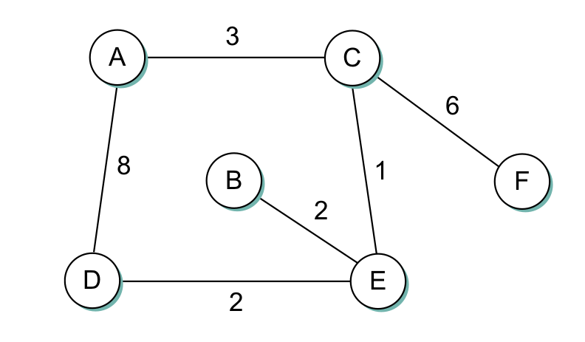

Q6: For the network graph in question 5 apply the Dijkstra algorithm and build the progress table for Node A.

Q7: An organization has been assigned the prefix 212.1.1/24 (class C) and wants to form subnets for four departments, with hosts as follows:

A - 75 hosts

B - 35 hosts

C - 20 hosts

D - 18 hosts

There are 148 hosts in all.

(a) Give a possible arrangement of subnet masks to make this possible.

(b) Suggest what the organization might do if department D grows to 32 hosts

A – 75 Hosts – 255.255.255.0

B – 35 Hosts – 255.255.255.128

C – 20 Hosts – 255.255.255.192

D – 18 Hosts – 255.255.255.224

The subnet mask is used so that the IP address can be divided using a sequence of 1’s followed by 0’s. We see the prefix 212.1.1 / 24 so the range is 192 to 223 therefore subnet mask = 255.255.255.0. Then

Nothing would change if department D grew to 32 because it can accommodate up to 32 hosts.

Q9. Why do you think IPv4 has fragment reassembly done at the endpoint, rather than at the next router?

IPv6 reassembles at the endpoint because the physical connection layer will make it better where it does not need to calculate on the header of the IP packet.

Q10. Having ARP table entries time out after 10 to 15 minutes is an attempt at a reasonable compromise. Briefly describe the problems that can occur if the timeout value is too small or too large.

If the timeout isn’t large enough the network may become cluttered with requests and half transmission until re-requests are answered. This amount of time is a reasonable minimum to allow for shut down, swap the ethernet card, and allow reboot.